21BDS0340

Abhinav Dinesh Srivatsa

Information Security and Audit Lab

Task – IV

**Question 1**

Aim: To configure a router with an access list

Tools and Concepts Required:

* Cisco Packet Tracer
* Switch
* Router
* Personal Computers
* Wiring

Output:

Create configuration:

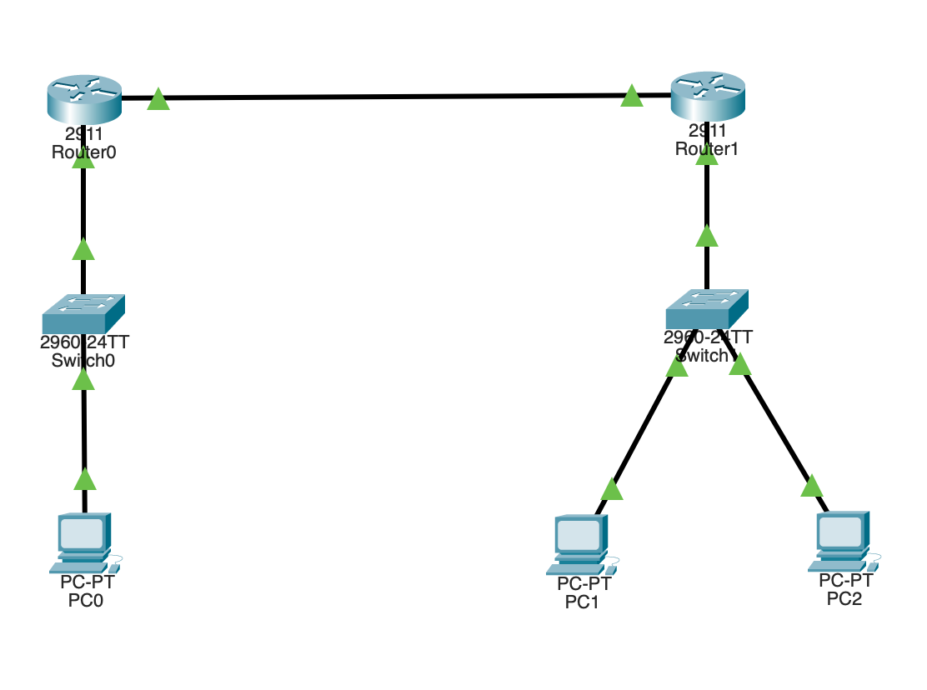

10.0.0.2 inaccessible from 20.0.0.2

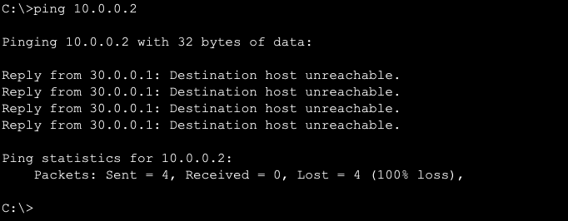

10.0.0.2 accessible from 20.0.0.3

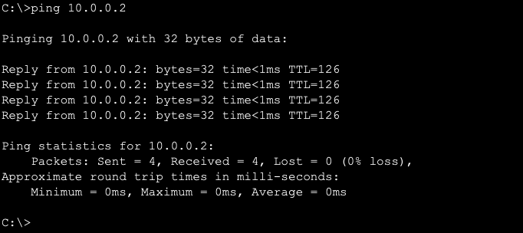

Result:

This network is secure, but all the nodes can only access to the router and any in the network they are assigned to and not to the rest of the internet. The implementation of selective permission for various computers.

**Question 2**

Aim: To configure a router with extended access list

Tools and Concepts Required:

* Cisco Packet Tracer
* Switch
* Router
* Personal Computers
* Wiring

Output:

Create configuration:

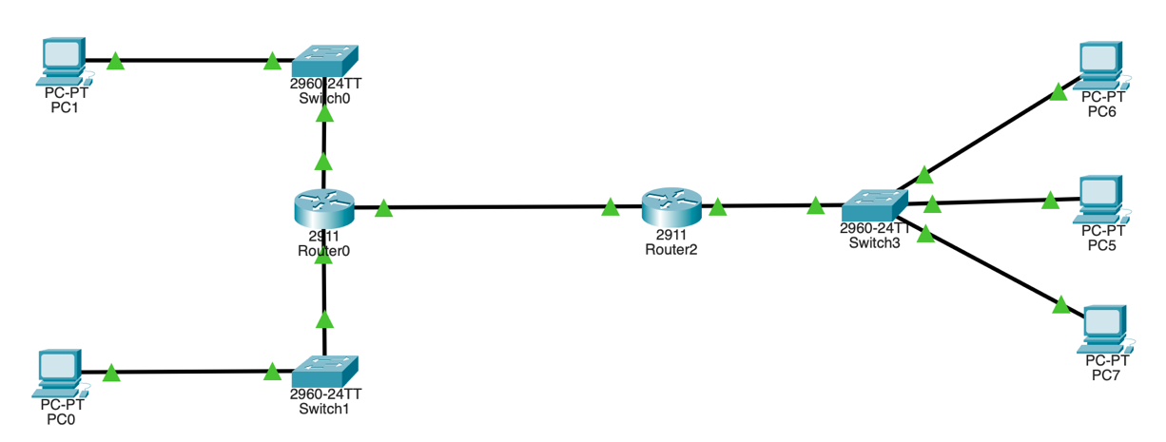

20.0.0.2 inaccessible from 30.0.0.2 and 30.0.0.3

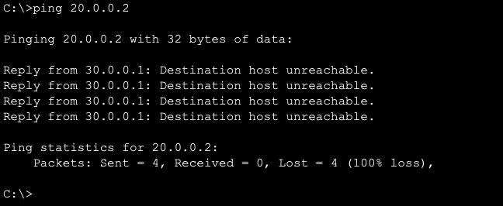

20.0.0.2 accessible from 30.0.0.4

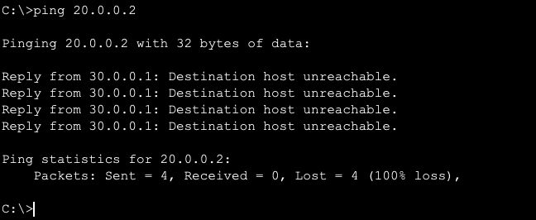

Result:

This network is secure, but all the nodes can only access to the router and any in the network they are assigned to and not to the rest of the internet. The implementation of selective permission for various computers. This setup allows for authorised individuals only to access a server.